Atari Legend Technical Documentation



CREATED ON : 01/05/2003 CREATED BY : Maarten Martens
LAST CHANGED ON : 03-02-2015 LAST CHANGED BY : Maartens Martens
DOCUMENT VERSION : 2.0

PROJECT : AL
DOCUMENT NAME : AL.DOC

Table of contents

Layout 3
Design 1 “AL – Legacy” 3
Coding 6
Simple rules 6
Extra technical info on the actual AL php code 7
Directory Structure 8
Tables 9
Games table 9
Menus tables 14
Doc tables 16
Screenshots tables 18
Review tables 19
Article tables 20
Interview tables 22
Publishers/Developers tables 23
Individuals 24
Music 25
Demos 26
Scene Genealogy 29
Comments 30
Users 31
Links/Website 31
News tables 32
Dump tables 33
Trivia tables 33
Magazine tables 34
Other tables 35

Layout

Design 1 “AL – Legacy”

This design is based on the free PSD file Robitic – Please see attached ‘robotic ui kit.psd’ file

You will find all info (color codes, sizes, graphical elements) of ‘AL-Legacy’ in the attached psd file ‘AL Legacy.psd’.

The legacy skin is based on a ‘tile’ system which makes it compatible to tablets and smart phones as well.

The Pages

Front page

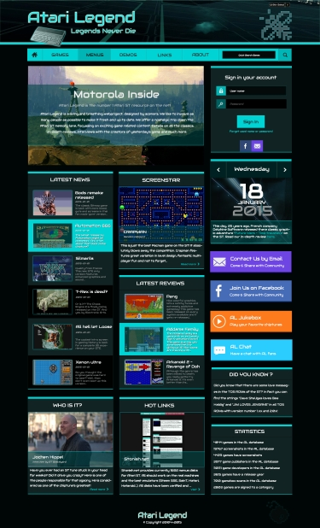

Top bar :
- Contains the skin selector which will be used to switch to different skins on the fly
- Picture of the 1040 ST will be randomized according to the date (This is possible with SMARTY - to avoid yet another table with skin specific graphical elements)

Top menu :
- This will lead to the different subsections as we know it
- A quick search which leads to the game detail page is available

Intro tile :
- The main message (in the shot – ‘Motorola Inside’) will change at each refresh
- The background shot will change to another piece of classic box art at each refresh

‘Sign In’ tile :
- Once logged in, a welcome message will appear in this tile, with a link to the profile page (and for admins an extra link to the admin panel)
- Logon using facebook account will be available as well

‘Latest News’ tile :
- The ‘Latest News’ title is a link which leads to the news main page when clicked
- Every news link will lead to the specific part in the newspage when clicked
- When visitor is logged in, ‘add news’ link will be available. → Do we want this? Or only on the news main page?
- When visitor is not logged in, ‘log in to add news’ will be shown → Do we want this? Or only on the news main page?

‘Screenstar’ tile :
- A new random game with a random comment will be shown at each refresh
- ‘Read more’ will lead to the game detail page of the game shown
- Pressing ‘Screenstar’ leads to the game search page

‘Date’ tile :
- The actual date with a fun fact of this day (if available)
- If there is no fun fact available, a link will appear which gives the user the possibility to add one
- If no fact is available and visitor is not logged on, message ‘please log on to provide a fun fact’ will appear

‘Latest Reviews’ tile :
- The ‘Latest Reviews’ title is a link which leads to the review main page when clicked
- Every review link will lead to the review page of that game
- When visitor is logged in, ‘add reviews’ link will be available. → Do we want this? Or only on the review main page?
- When visitor is not logged in, ‘log in to add review’ will be shown → Do we want this? Or only on the review main page?

‘Contact by email’ tile :
- Sent email to info@atarilegend, when logged in.
- If visitor is not logged in ‘log in to sent email’ will appear → is this ok?

‘Facebook’ tile :
- Leads to AL’s facebook page

‘Jukebox’ tile :
- Opens the juckebox in new tab or pop up

‘AL Chat’ tile :
- Opens the chat box in new tab or pop up

‘Did You Know’ tile :
- A new fact at every refresh

‘Who is it’ tile :
- A new random interview with picture is shown at refresh
- ‘Read more’ will lead to the interview page
- ‘Who is it’ will lead to the interview main page

‘Hot Links :
- A new random link with picture is shown at refresh
- ‘visit’ will open up the webstie in new tab or page
- ‘Hot Links’ will lead to the links main page

‘Statistics’ tile :
- Up to date stats of the site

Coding

Simple rules

Things we always need to think about when we are coding our site (from http://www.zend.com/zend/tut/tut-hatwar.php ) :

- Filename : sectionname_description.php
- Every file will have a header with the version and update info :

/************************************************************************************
* Filename
* -------------------------------
* begin : date (when is the file created)
* copyright : (C) 2003 Atari Legend
* email : email adres of creator
* actual update : info on the update of the file
*
* Id: filename, version nr, update date, hour of update, who updated
*
**************************************************************************************/

- Try and avoid the use of select "*" in select statements!
- Use a line for each statement in a select :

  - SELECT
member_id,
review_text,
review_date,
review_score_id,
review_graphics,
review_sound,
review_gameplay,
review_overall
FROM review_game
LEFT JOIN review_main ON …

- Make use of the list statement
- Variable names :
  - table variables : v_tablefieldname → eg. v_game_id
  - select statement vars : $sql_tablename (mother table in joins)
  - query statement vars : $query_tablename

- Keep function names to the point!
- Try and use as little javascript as possible
- Use the header functions – no more javascript redirecting
- Divide and conquer : Code in separate modules. All the modules together will build the site. Let each module have the functionality it absolutely needs and stop there. Do nothing more and nothing less. Adding functionality that's not needed results in data traveling in pipes that run awry. You know the rest.
- Separate code, content and presentation
- Make code re-usable : Use function modules, separate forms …
- Build for speed : As a rule of thumb, if your application sends more than 40 KB of data or if your page requires more than 5 seconds to load, it is time to take the application back to the drawing board. Don’t use unnecesary cookies!!! Ensure that your code runs fast. Nobody likes waiting.
- Secure your code : Ensure that your code runs securely at all times.
- Keep it simple : Ensure that your code is documented, simple, and easy to comprehend. It helps in the long run.
- CSS classes : we use the section name and what it is used for. Let’s say a certain class represents the title of a news announcement, this class is called : news_title. If a certain class is used all over the site, the class name starts with “main_” and the usage…eg. main_text.

Extra technical info on the actual AL php code

The whole AL projects runs on php, mysql and the Smarty templating system. To let you know how the complete motor runs, I will explain it with an example. Let’s take the default news page. This is the page you see when you will surf to www.atarilegend.com . Before I explain further, I want to say that the site is build up out of 4 sections. First we have the top and left side (which are fixxxed and won’t change when browsing through the pages). The other 2 sections are dynamic, and can change according to each link clicked. Those sections are the center section and the right side.

When the visitor visits for the first time, the news section is called. The news section will have in the left side the links to the other parts of the site, in the center the news updates and on the right some extra stuff (like a hotlinks box). So now the appropriate news files are called. We have the news.php file (which will get all news updates out of the DB) and the link_minute.php file (which will get a random link from the DB).

Okay, so far so good. Since we are using a template system, all code is divided from layout. So here the templating is gonna kick in. For layout we have an index.tpl file. This index file will place all the appropriate sections on screen.

Let’s get on with the news page. So now you know which files are called, let’s look at them in more detail. The news.php file gets the data from the DB and it uses the Smarty fucntions to place it all in the layout. But not yet. Remember I said the layout also had an index.tpl file? Well this file is based _TPL variables. The news.php file will fill its news_TPL variable with a value of ‘1’. The link_minute.php file will fil its link_minute_TPL with ‘1’. In the index.tpl file has a if structure that will make sure the correct SUB sections are called to be placed in the layout. For this page a news.tpl sub file is called and a link_minute.tpl sub file for the right side. So when all the php files have retrieved all data and filled all the correct variables, we call the index.tpl file which will build the site completely as wished!

For more info, please check the documented code in the php and tpl files!

Directory Structure

This is the dir structure on the server. It will include the CPANEL and the actual WEBSITE.
Some dirs are not explained, they will be removed after cleanup.

Atarilegend
- about (the about page)
- admin (the admin control panel main folder)
  - administration (statistics page)
  - company (company edit pages)
  - crew (crew edit pages)
  - demos (demo edit pages)
  - games (game edit pages)
  - includes
  - individuals (individual edit pages)
  - interviews (interview edit pages)
  - libs (Smarty template library files)
  - links (links edit pages)
  - magazine (magazine edit pages)
  - news (news edit pages)
  - templates (the templates folder for the admin page)
    - 0 (main template files for admin pages)
  - Trivia (trivia edit pages)
  - Updates
  - User (user logs, stats and edit pages)
- Blab (the blab AL chat folder)
- Configs (folder used by Smarty template system)
- Contact (the main contact page and the Andreas memory page)
- Data (the website data folder)
  - Images (all images used on the site)
    - Article screenshots
    - Company logo’s
    - Crew logo’s
    - Demo screenshots
    - …
  - Music (music data)
    - Games
    - Demos
  - Zips (the actual games and demos for download)
    - Gamers
    - Demos
    - Temp
- Disclaimer (the disclaimer page)
- Extras (extras like trivia…)
- Games (all the files for the game pages)
- Includes (main site includes folder)
- Interviews (the interview pages)
- Libs (Smarty template library folder)
- Links (the links pages)
- Logon (the log on pages)
- Music (the al Jukebox main code)
- News (the news pages)
- Newsattach
- Reviews (the main review pages)
- Templates (the main website template code)
- Templates_c (template cach folder for Smarty)
- Wendy (the wanted games lists)
- Zips (the actual games and demos for download)
  - Gamers
  - Demos
  - Temp

Tables

Games table

Layout of table :

The main game table which holds the name of all games

game
game_id → int (auto)(primary key)(unique)
game_name → varchar (Name of game)

Alternative names for games are stored in here.

game_aka
game_aka_id → int (auto)(primary key)(unique)
game_id → int
aka_name → varchar (Name of game)

The release year is stocked in here for each game

game_year
game_year_id → int (auto)(primary key)(unique)
game_id → int (foreign from game table)
game_year → varchar (release year)
game_extra_info_id → int

The categories of games eg. shooters, Beat 'em ups, strategy and so on.

game_cat
game_cat_id → int (auto)(primary key)(unique)
game_cat_name → varchar (name of category)

game_cat_cross
game_id → int (foreign key from the demo table)
game_cat_id → int (foriegn key from the demo_cat table)

The download table allows for multiple disks download but thats not everything it also allows for different versions of the game, like different cracks and trainers, if that should prove to be neccesary. The first 3 fields make for the unique key. Set_nr has been added for games on multiple disks. Take “GODS” for example. We add a version to the DB. 2 records (2discs). No problem here. When we add another crack, we have again 2 records. Which recs belong to eachother for this game? The set_nr fixxxes this!

game_download
game_download_id → int (auto)(primary key)(unique)
game_id → int (foreign key from the game table)
set_nr → int (multiple disk sets)
game_ext → varchar (extension of file)
date → date (upload date)
md5 → varchar (checksum)
cracker → varchar (hacked by?)
screen → varchar (pal/ntsc?)
language → varchar (language of game release)
trainer → varchar (trained or not)
disks → int (disk_nr)
legend → int (legend release)
Harddrive → varchar (hd installable)
Intro → varchar (intro by)
Disable → varchar (disable download)

Keep track of the downloads … who downloads what?

game_download_info
game_download_info_id → int (auto)(primary key)(unique)
game_download_id → int (foreign key from the game table)
game_download_size → varchar (size of disk)
user_id → int (which user?)

Game localization or Multilingo games.

lingo
lingo_id → int (auto)(primary key)(unique)
lingo_name → varchar (name of language)

lingo_game
lingo_game_id → int (auto)(primary key)(unique)
lingo_game_name → varchar (name of game in localized language)
lingo_id → int (foreign from the lingo table)
game_id → int (foreign from the game table)

And so we come to the similar/related games, this is a simple cross table that crosses one game with another.

game_similar
game_similar_id → int (auto)(primary key)(unique)
game_id → int (foreign key from the game table)
game_similar_cross → int (key from the game table)

And here we have the missing games or wanted games table

game_wanted
game_wanted_id → int (auto)(primary key)(unique)
game_id → int (foreign key from the games table)
game_wanted_comment → varchar (comments on the game)

This is the diskscan table

game_diskscan
game_diskscan_id → int (auto)(primary key)(unique)
game_id → int (foreign key from the games table)
game_diskscan_filename → varchar (name of file)

And so we go on to the imagegallery for the games, alternative art and such.

game_gallery
game_gallery_id → int (auto)(primary key)(unique)
game_id → int (foreign key from games)
image_ext → varchar
game_description_gallery → text (field to describe what picture is)

The boxscans in the table below are separeted from the rest of the imggallery. They contain a unique key which is linked to the file on the HD. The file is build like boxscan_id.png!

game_boxscan
game_boxscan_id → int (auto)(primary key)(unique)
game_id → int (Foreign key from games db)
imgext → varchar (the type of image)
game_boxscan_side → varchar (front '0', back '1')

game_box_couples
game_box_couples_id → int (auto)(primary key)(unique)
game_boxscan_id → int (foreign key from the game_boxscan table)
game_boxscan_cross → int (key from the game_boxscan table)

This crosstable links front and back covers with eachother!

game_series
game_series_id → int (auto)(primary key)(unique)
game_series_name → varchar (name of series)

game_series_cross
game_series_cross_id → int (auto)(primary key)(unique)
game_id → int (foreign key from game table)
game_series_id → int (foreign from game_series table)

game_user_comments
game_user_comments_id → int (primary key)(auto)(unique)
game_id → int (foreign key with game table)
comment_id → int (foreign key with comment table)

This table contains comments by visitors of the site.

game_author
game_id → int (foreign key from game table)
ind_id → int (foreign key from individual table)
author_type_id → int (foreign key from author_type)

This is a cross table with the Author(s) of the game!

game_submitinfo
game_submitinfo_id → int
game_id → int
user_id → int
timestamp → varchar
submit_text → text
game_done → varchar (submission has been entered in the DB)

This table is used for the game info submit page. People can send in extra info for a game and it will be placed in here before validation

game_free
game_id → int
free → int

When a game is a free (pd, freeware) title, it is saved in here!

game_falcon_enhan
game_id → int
falcon_enhanced → int (0 or 1)

Falcon enhanced games are linked in here

game_falcon_only
game_id → int
falcon_only → int (0 or 1)

Falcon only games are linked in here

game_mono
game_id → int
monochrome → int (0 or 1)

Mono games are linked in here

game_ste_enhance
game_id → int
ste_enhanced → int (0 or 1)

STE enhanced games are linked in here

game_ste_only
game_id → int
ste_only → int (0 or 1)

STE only games are linked in here

game_unfinished
game_id → int
unfinished → int (0 or 1)

unfinished games are linked in here

game_stac
game_id → int
stac → int (0 or 1)

Games created with the adventure creator

game_unreleased
game_id → int
unreleased → int (0 or 1)
admin_text → text (comments by the admins)

unreleased games are linked in here

game_extra_info
game_extra_info_id → int
game_extra_info → varchar

This table holds extra terms we use to link to publishers eg. Budget, Arcade …

game_vs
amiga_id → int
atari_id → int
c64_id → int

Link to the Lemon sites for comparison links of the games to other versions.

Graphical version :

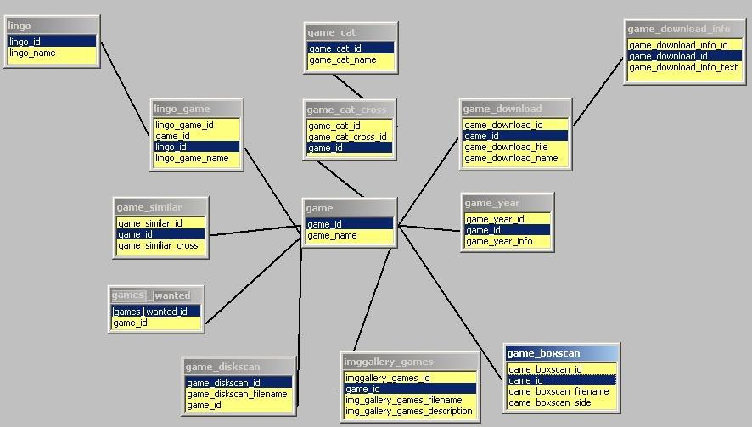

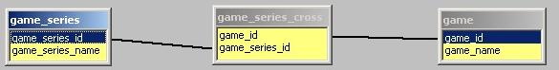

Menus tables

The following tables will connect all games to their hack menu’s. This is an important feature of the site!

Layout of tables :

menu_type
menu_type_id → int (auto)(Primary key)(unique)
menu_types_main_id → int (Foreign key from menu_types)
menu_sets_id → int (Foreign key from menu_sets table)

this table connects all menu_sets to a certain type of menu! Cross-table!

menu_types_main
menu_types_main_id → int (auto)(Primary key)(unique)
menu_type_text → varchar (the actual menu types)

this table contains the menu types eg. Demo menu, game menu, tool menu…

menu_set
menu_sets_id → int (auto)(Primary key)(unique)
menu_sets_name → varchar (Name of "set")
Many crews made different "sets" of menu disks. One example would be the pompey pirates, they had 2 sets, one named nothing and the other one named "Krappy compacts". The one named nothing, will need a name as well. I Suggest "Compact Disks" or "Compacted Disks". This makes this table essential to have otherwise we would have conflicts.

menu_sets_order
menu_sets_id → int (Primary key)(unique)
menu_sets_start → varchar (starting number of menu disc in set)
menu_sets_end → varchar (final number of menu disc in set)
menu_sets_order → varchar (DESC/ASC : how it is ordered)

This table is needed specifically for putting the discs in the correct way on screen.
We need to know how many discs are released, which number they start and end, gaps, how they are ordered ...

menu_disk
menu_disk_id → int (auto)(Primary key)(unique)
menu_sets_id → int (Foreign key from menu_sets)
menu_disk_number → varchar (the Menu number)
menu_disk_letter → varchar (Which part; a,b,c,d and so on)
menu_disk_part → varchar (The part; part 1, part 2, part 3 and so on)
menu_disk_version → varchar (The version of the disk; version 1…)

This is the main table for the menu disks. Every menu disk belongs to a set , hence the set ID. Eg Atari Legend menu disk 4 part 3 disk b version 2. Menu disks can contain all kinds of software. So we use the following table to break them in parts of games, tools, demos and so on. They are all connected to their menu. This is the Type table (thought it is called title table here).

menu_disk_title
menu_disk_ title_id → int (auto)(Primary key)(unique)
menu_disk_id → int (Foreign key)
menu_disk_title_type → varchar (What type of title is it? Game, Tool, Doc…)

The following tables contain all the software according to type on their menu disk. We need all these tables so we can enhance search features on the site and for data consistency. Thanks to these tables one can search for a type of software on a menudisk. Instead of the usual name search on menudisks.

menu_disk_title_game
menu_disk_title_game_id → int (auto) (Primary key)(unique)
menu_disk_title_id → int (Foreign key)
game_id → int (Foreign key from the games table)
demo_version → int (demo versions)

menu_disk_title_doc_tools
menu_disk_title_docs_id → int (auto) (Primary key)(unique)
menu_disk_title_id → int (Foreign key)
doc_tools_id → int (Foreign key from the docs table)

menu_disk_title_doc_games
menu_disk_title_docs_id → int (auto) (Primary key)(unique)
menu_disk_title_id → int (Foreign key)
doc_games_id → int (Foreign key from the docs table)

menu_disk_title_tools
menu_disk_title_tools_id → int (auto) (Primary key)(unique)
menu_disk_title_id → int (Foreign key from menu_disk_title table)
tools_id → int (Foreign key from the tools table)

menu_disk_title_various
menu_disk_title_various_id → int (auto) (Primary key)(unique)
menu_disk_title_id → int (Foreign key)
menu_disk_title_various → varchar (info, fonts, pictures)

menu_disk_title_demo
menu_disk_title_demo_id → int (auto) (Primary key)(unique)
menu_disk_title_id → int (Foreign key from menu_disk_title table)
demo_id → int (Foreign key from the demo table)

menu_disk_title_music
menu_disk_title_music_id → int (auto) (Primary key)(unique)
menu_disk_title_id → int (Foreign key from menu_disk_title table)
music_id → int (Foreign key from the music table)
menu_user_comments
menu_user_comments_id → int (primary key)(auto)(unique)
menu_disk_id → int (foreign key with menu_disk table)
Comment_id → int (foreign key with comment table)

Graphical version :

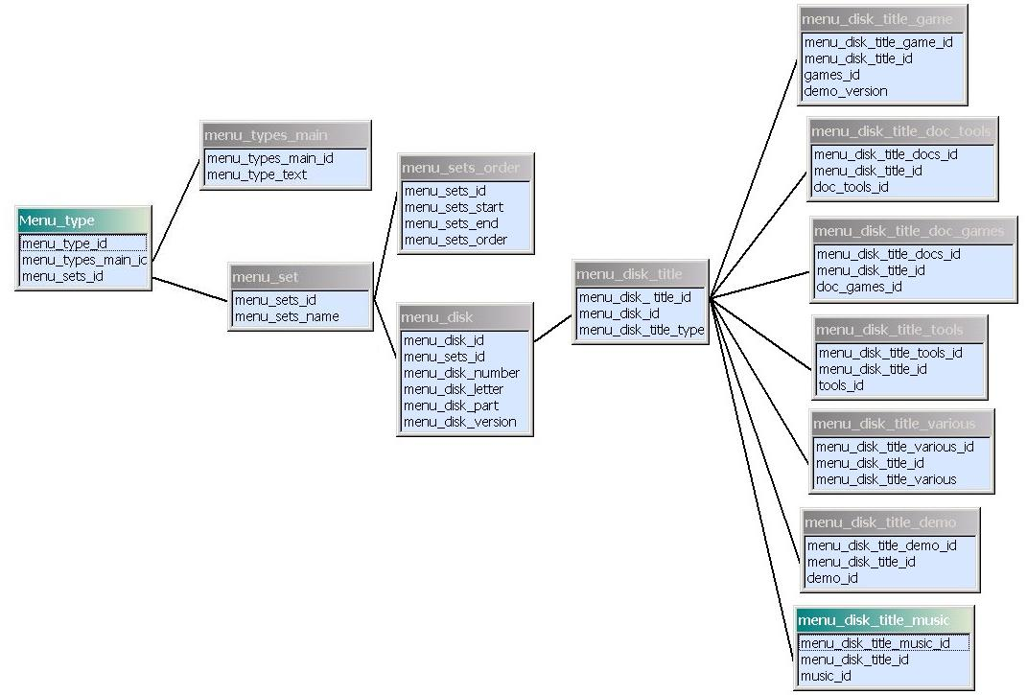

User comments table missing on this picture!

Doc tables

The following tables contain the docs. We have divided the docs in two categories, there are only game docs and tool docs. Our theory, if it is not a game doc, it certainly is a tool doc! This to make things a bit more simple!

Layout of tables :

doc_category
doc_category_id → int (auto)(primary key)(unique)
doc_category_name → varchar (is it a tool doc, or a game doc?)

Is it a tool doc, or a game doc?

doc_type
doc_type_id → int (auto)(primary key)(unique)
doc_type_name → varchar (what type – doc, tut, tips, solution…)
doc_category_id → int (foreign key form doc_category)

We have included this table to divide the docs even further into types. Now people can for example do a search for a solution for kings quest, or a cheat for super cars 2 …

doc_game
doc_games_id → int (auto)(primary key)(unique)
game_id → int (foreign key to games table)
doc_type_id → int (foreign key from doc_type)

doc_tools
doc_tools_id → int (auto)(primary key)(unique)
tools_id → int (foreign key from the tools table)
doc_type_id → int (foreign key from doc_type)

Here the actual docs are connected to their tool or game. We need al this info, of course. If you check out the menus tables above, you’ll notice that they are also connected to their doc tables (just see the last branch in the graphical version), this way, we can see on what menu the doc is to be found!

Graphical version :

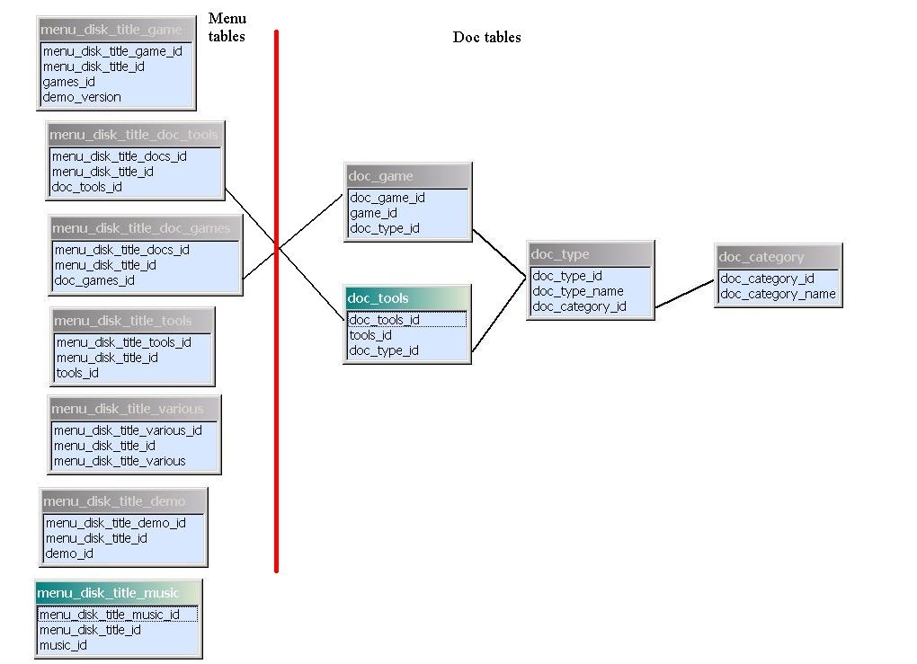

Screenshots tables

Layout of tables :

screenshot_main
screenshot_id → int (auto)(Primary key)(unique)
imgext → varchar

This table contains only the unique key of all screenshots used. This key is linked too the file on the HD. The file is build like screenshot_id.png!

screenshot_game
screenshot_game_id → int (primary key)(unique)(auto)
game_id → int (Foreign key from games db)
screenshot_id → int (Foreign key from main_screenshot db)

This table cotains all game screenshots

screenshot_demo
screenshot_demo_id → int (primary key)(unique)(auto)
demo_id → int (Foreign key from demo db)
screenshot_id → int (Foreign key from main_screenshot db)

This table cotains all demo screenshots

screenshot_review
screenshot_review_id → int (primary key)(unique)(auto)
review_id → int (Foreign key from the review db)
screenshot_id → int (Foreign key from main_screenshot db)

This table contains links to the screenshots used in the reviews.

screenshot_ gameinfo
screenshot_ gameinfo_id → int (auto)(unique)(primary)
game_id → int (Foreign key from games db)
screenshot_id → int (Foreign key from main_screenshot db)

This table contains links to the screenshots used in main game info sections.

screenshot_article
screenshot_ article_id → int (Primary key)(unique)(auto)
article_id → int (Foreign key from the review db)
screenshot_id → int (Foreign key from main_screenshot db)

This table contains links to the screenshots used in the articles.

screenshot_interview
screenshot_interview_id → int (primary key)(unique)(auto)
interview_id → int (Foreign key from the interview db)
screenshot_id → int (Foreign key from main_screenshot db)

This table contains links to the screenshots used in the interviews.

Graphical version :

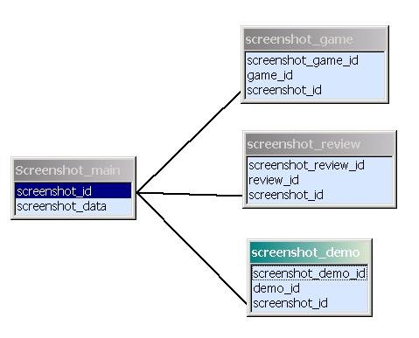

screenshot_article, screenshot_game_info are not shown on this pic!

Review tables

These tables contain the actual reviews of the games over at AL.

Layout of tables :

review_main
review_id → int (auto)(primary key)(unique)
member_id → int (Foreign to a members table - who wrote it?)
review_text → text (the actual review)
review_date → int (the date of the review)
review_edit → int (is this an uploaded review by a visitor and does it
still need to be checked?)

This is the main review table. It basically stocks the reviewed game and the person who wrote it.

review_game
review_game_id → int (auto)(primary key)(unique)
review_id → int (Foreign key to review table)
game_id → int (Foreign key to game table)

This table contains all game reviews

review_demo
review_demo_id → int (auto)(primary key)(unique)
review_id → int (Foreign key to review table)
demo_id → int (Foreign key to demo table)

This table contains all demo reviews

…

review_score
review_score_id → int (auto)(unique)(primary)
review_id → int (foreign key to review table)
review_graphics → varchar (score)
review_sound → varchar (score)
review_gameplay → varchar (score)
review_overall → varchar (score)

This table holds all the scores a game got in a review.

review_comments
review_comment_id → int (auto)(unique)(primary)
screenshot_review_id → int (foreign key to review_screenhot table)
comment_text → text (the actual comment with a screenshot)

This table holds the comments for a screenhot in a review. It is connected to the review_screenshot table as seen in the screenshot section (or on the picture below).

review_user_comments
review_user_comments_id → int (primary key)(auto)(unique)
review_id → int (foreign key with review table)
comment_id → int (foreign key with comment table)

This table has got nothing to do with the screenshots comments. This is a crosstable to the comment table, people can give their opinion on the review in here!!!

Graphical version :

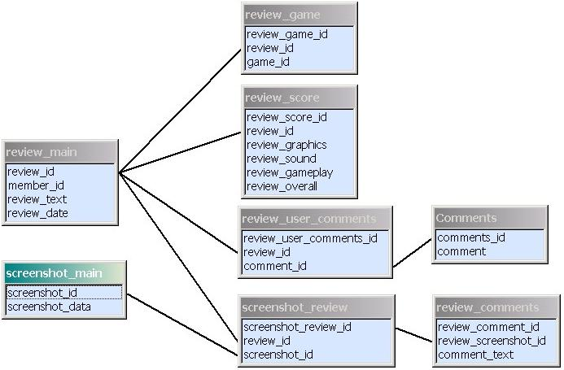

On this shot you see how a review is build. With a combination of review and screenshot tables. This way of thinking makes it possible for a screenshot to be used more than once on the same review.

Article tables

The articles will be build in the same way as the reviews. So their table structure will be similar.

Layout of tables :

article_main
article_id → int (auto)(primary key)(unique)
member_id → int (Foreign to a members table - who wrote it?)
article_type_id → int (Foreign to type of article)

This is the main artilce table. It basically stocks the article and the person who wrote it. An article is not connected to a game.

article_text
article_text_id → int (auto)(primary key)(unique)
article_id → int (Foreign to article main)
article_title → text (the title of the article)
article_text → text (the actual review)
article_date → date (the date of the review)

The actual articles

article_type
article_type_id → int (auto)(primary key)(unique)
article_type → varchar (the actual article type)

This table contains article types, to divide it into demo, game, program articles…

article_comments
article_comment_id → int (auto)(unique)(primary)
screenshot_article_id → int (foreign key to review_screenhot table)
comment_text → text (the actual comment with a screenshot)

This table holds the comments to the screenshot used in the article. It works in the same fashion as with the reviews…

article_user_comments
article_user_comments_id → int (primary key)(auto)(unique)
article_id → int (foreign key with article table)
comment_id → int (foreign key with comment table)

This table has got nothing to do with the screenshots comments. This is a crosstable to the comment table, people can give their opinion on the article in here!!!

Graphical version :

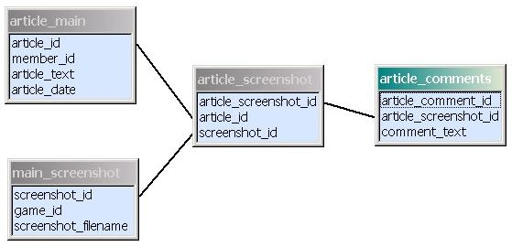

An article connected to its screenshots

Interview tables

The interviews will be build in the same way as the reviews. So their table structure will be similar.

Layout of tables :

interview_main
interview_id → int (auto)(primary key)(unique)
member_id → int (Foreign to a members table - who wrote it?)
ind_id → int (Foreign to individual table - who is interviewed?)

This is the main interview table. It basically stocks the interview and the person who wrote it. An interview is not connected to a game, but to an individual.

interview_text
interview_text_id → int (auto)(primary key)(unique)
interview_id → int (Foreign to article main)
interview_text → text (the actual review)
interview_date → date (the date of the review)
interview_intro → text (an introduction to the interviewee)
interview_chapters → text (in here the chapters are stored)

The actual interviews

interview_comments
interview_comment_id → int (auto)(unique)(primary)
screenshot_interview_id → int (foreign key to review_screenhot table)
comment_text → text (the actual comment with a screenshot)

This table holds the comments to the screenshot used in the interview. It works in the same fashion as with the reviews…

interview _user_comments
interview_user_comments_id → int (primary key)(auto)(unique)
interview_id → int (foreign key with article table)
comment_id → int (foreign key with comment table)

This table has got nothing to do with the screenshots comments. This is a crosstable to the comment table, people can give their opinion on the interview in here!!!

Publishers/Developers tables

The following tables will stock the pub/dev of the games. Keep in mind we are, most of the time, talking about companies here. But this is not always the case …

Layout of tables :

pub_dev
pub_dev_id → int (auto)(primary key)(unique)
pub_dev_name → varchar (Name of company/person)

This is the main table which holds all companies

pub_dev_text
pub_dev_text_id → int (auto)(primary key)(unique)
pub_dev_id → int (foreign to pub_dev)
pub_dev_profile → text (some history)
pub_dev_imgext → varchar (img extension for logo)

extra company info

game_developer
dev_pub_ id → int (foreign key from pub_dev)
games_id → int (foreign key from the games table)
continent_id → int (foreign key from the continent table)
game_extra_info_id → int (foreign key from the game_extra_info table)

game_publisher
pub_dev_id → int (foreign key from pub_dev)
games_id → int (foreign key from the games table)
continent_id → int (foreign key from the continent table)
game_extra_info_id → int (foreign key from the game_extra_info table)

These are 2 examplary cross tables … this way, we connect the pub/dev to their games. We can do the same with tools, demos and other sections of the site by just adding tables like this!

Graphical version :

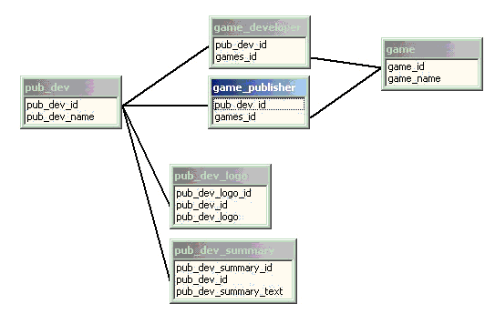

In this picture you can see how pub/devs are connect to their games using the crosstables.
(the logo and summary = profile can be found in the text table)

Individuals

The following tables will stock the individuals. Sceners, game/demo creators, musicians … These tables are used in various structures all over the DB.

Layout of tables :

individuals
ind_id → int (primary key)(auto)(unique)
ind_name → varchar (name of someone involved in game development)

individual_text
ind_text_id → int (primary key)(auto)(unique)
ind_id → int (foreign key to individuals)
ind_profile → text (extra info)
ind_imgext → varchar
ind_email → varchar

Every individual used to have a nickname. Those names are stored in the following table. If person should not have a real name, a nick is used in the Individual table above!

individual_nicks
individual_nicks_id → int (primary key)(auto)(unique)
ind_id → int (foreign key from individual table)
nick → varchar (the nickname for the person)

This table holds all the types of people involved in the creation of a product. Like the coders, the graphics artists, producer, musicians …

author_type
author_type_id → int (primary key)(auto)(unique)
author_type_info → varchar (producer, coder, musician…)

This table holds the actual individual and his job within a certain project.

author
author_id → int (primary key)(auto)(unique)
individual_id → int (foreign key from individual table)
author_type_id → int (foreign key from author_type)

Graphical version :

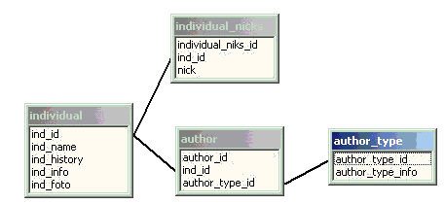

Music

The following tables will stock all music info and everything surrounding it!

Layout of tables :

The main music table.

music
music_id → int (primary key)(auto)(unique)
imgext → varchar (name of the extension used)
music_desc → text (some info on the file – intro, levelmusic…)

The crosstable between music and types.

music_types
music_types_main_id → int (foreign key with types table)
music_id → int (foreign key with music table)

The main music types table eg … snd files, ym files ….

music_types_main
music_types_main_id → int (primary key)(auto)(unique)
music_types_name → varchar (name of the type of music file)
extention → varchar

A cross table between music and the authors of the piece

music_author
music_id → int (Foreign key from the music table)
ind_id → int (Foreign key from the individual table)

An example of a crosstable between music and it’s software … here demos!

demo_music
demo_id → int (Foreign key from the demo table)
music_id → int (Foreign key from the music table)

music_user_comments
music_user_comments_id → int (primary key)(auto)(unique)
music_id → int (foreign key with music table)
comment_id → int (foreign key with comment table)

Graphical version :

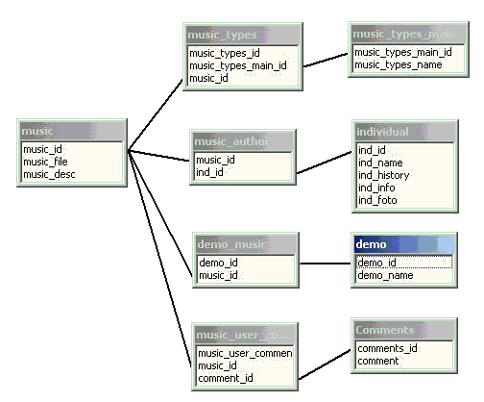

This structure has a bit of it all. This is how all data for a music file is connected with eachother…(old version)

Demos

The following tables will stock the demos and all its extras

Layout of tables :

The main _cat table

demo
demo_id → int (primary key)(auto)(unique)
demo_name → varchar (name of the demo)

demo_aka
demo_aka_id → int (auto)(primary key)(unique)
demo_id → int
aka_name → varchar (Name of demo)

demo_year
demo_year_id → int (auto)(primary key)(unique)
demo_id → int
demo_year → varchar

Here is the main category table eg mega demo, intro ...

demo_cat
demo_cat_id → int (primary key)(auto)(unique)
demo_cat_name → varchar (name of the category)

And now for the category crossing with demos, allowing multiple categories for each demo.

demo_cat_cross
demo_id → int (foreign key to the demo table)
demo_cat_id → int (foreign key to the demo_cat table)

The following is the compability and info table.

demo_info
demo_info_id → int (primary key)(auto)(unique)
demo_id → int (foreign key with the demo table)
demo_info_text → text (the information)

Which demos work with an emu?

emulator
emulator_id → int (primary key)(auto)(unique)
emulator_name → varchar (emulator name)

The crosstable with the demos and the emus…

demo_Emulator
demo_id → int (foreign key with demo table)
emulator_id → int (foreign key with emulator table)

The next table will have the actual demo files!

demo_download
demo_download_id → int (primary key)(auto)(unique) demo_id → int (foreign key with demo table)
demo_download_file → varchar (filename)
demo_download_name → varchar (disk one, disk two …)

demo_author
demo_id → int (foreign key from demo table)
ind_id → int (foreign key from individual table)
author_type_id → int (foreign key from author_type)

This is a cross table with the Author(s) of the demo!

demo_falcon_enhan
demo_id → int
falcon_enhanced → int (0 or 1)

Falcon enhanced demos are linked in here

demo_falcon_only
demo_id → int
falcon_only → int (0 or 1)

Falcon only demos are linked in here

demo_ste_enhance
demo_id → int
ste_enhanced → int (0 or 1)

STE enhanced demos are linked in here

demo_ste_only
demo_id → int
ste_only → int (0 or 1)

demo_mono_only
demo_id → int
mono_only → int (0 or 1)

STE only demosare linked in here

demo_submitinfo
demo_submitinfo_id → int
demo_id → int
user_id → int
timestamp → varchar
submit_text → text
demo_done → varchar (submission has been entered in the DB)

This table is used for the demo info submit page. People can send in extra info for a demo and it will be placed in here before validation

For demos that belong into the same serie …

demo_series
demo_series_id → int (primary key)(auto)(unique)
demo_series_name → varchar (name of series … union …)

demo_series_cross
demo_id → int (foreign key with demo table)
demo_series_id → int (foreign key with demo series table)

demo_user_comments
demo_user_comments_id → int (primary key)(auto)(unique)
demo_id → int (foreign key with demo table)
comment_id → int (foreign key with comment table)

Graphical version :

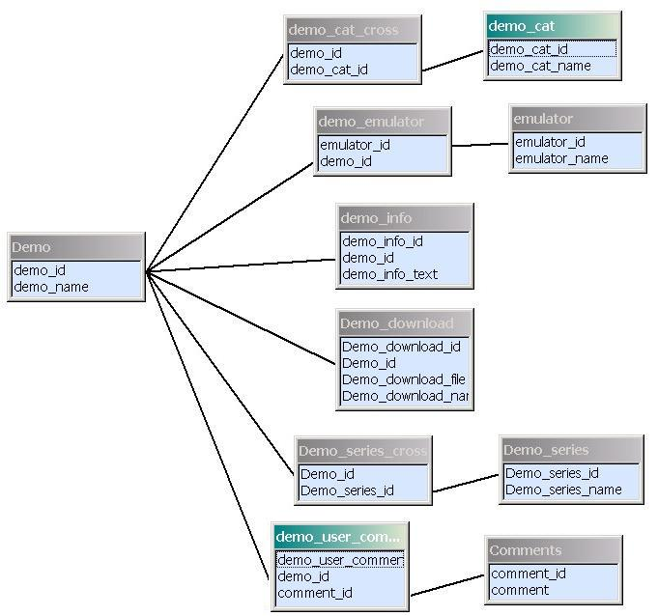

Scene Genealogy

Another big, complex part of the website. These table hold all date on crews and individuals. There complete relationship with eachother and their work.

Layout of tables :

We start with the individuals (hackers, coders, musicians)…These individuals belong to a certain crew, or they might work on their own. We have a cross table connected between them, the crew_individual table. Certain crews also have subcrews, ergo the subcrew table!

Here are some of the table structures … since this complete structure mostly consist of other tables explained above, or cross tables, not all tables are discussed.

crew
crew_id → int (primary key)(auto)(unique)
crew_name → varchar (the name of the crew)
crew_logo → varvhar (link to logo picture)
crew_info → text (some extra info on the crews)
crew_history → text (some on the history of the crew)

sub_crew
sub_crew_id → int (primary key)(auto)(unique)
crew_id → int (foreign key with crew table)
parent_id → int

Every crew or individual has got their own productions, these are always demos or menus. Games are dealt with in the game tables structure! So, as seen on the grafic below, there are 4 cross tables to connect both groups to their productions (demos or menus).

Graphical version :

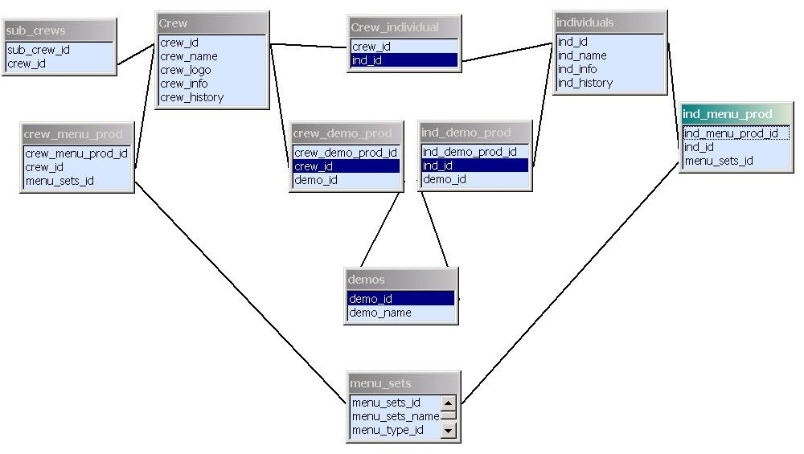

Comments

This structure consist of only 1 table linked with cross tables to the demo, menu, reviews, articles, games section... Check out the picture of the demo section for this table structure.

Layout of tables :

Comments
comments_id → int (primary key)(auto)(unique)
comment → text (the actual comment)
user_id → int (who posted the comment)
timestamp → date (when did he post the comment)

Users

The users of the website, sceners and others. For example used with reviews – which member wrote a review?

Layout of tables :

Users
user_id → int (primary key)(auto)(unique)
userid → varchar (eg. ST Graveyard)
password → varchar (users password)
email → text (email)
permission → Int (user permission)
session → varchar (store the session id when cookie is created)
join_date → varchar (When did the user join?)
last_visit → varchar (when did the user visit the site last?)
user_website → varchar
user_icq → varchar
user_msnm → varchar
user_aim → varchar

Links/Website

This is the place for all the the favorite links of AL.

Layout of tables :

website
website_id → int (primary key)(auto)(unique)
website_name → varchar
website_url → varchar
website_date → int (when was the link added)
website_user_sub → varchar (who added the link)
website_imgext → varchar
website_count → int
rate_number → int
rate_score → int
user_ip → varchar

website_category
website_category_id → int (primary key)(auto)(unique)
website_category_name → varchar
parent_category → int (foreign key to website category)

website_category_cross
website_category_cross_id → int (primary key)(auto)(unique)
website_id → int (foreign to website)
website_category_id → int (foreign to website_category)

website_description
website_description_id → int (primary key)(auto)(unique)
website_id → int (foreign to website)
website_description_text → varchar

website_validate
website_id → int (primary key)(auto)(unique)
website_name → varchar
website_url → varchar
website_date → int
website_category → int
website_description → text
user_id → Int (foreign key to user table)

News tables

These contain all data regarding the news updates on the site!

Layout of tables :

news
news_id → int (primary key)(auto)(unique)
news_headline → varchar
news_text → text
news_image_id → int (foreign key to news_image table)
user_id → int (foreign key to user table)
news_date → int
news_type → char

news_image
news_image_id → int (primary key)(auto)(unique)
news_image_ext → varchar

news_submission
news_submission _id → int (primary key)(auto)(unique)
news_headline → varchar
news_text → text
news_image_id → int (foreign key to news_image table)
user_id → int (foreign key to user table)
news_date → int
news_type → char

These tables are used for faster searching on the news page. Each word from a news announcement is saved in the wordlist table (unless it was saved prior to this one). The wordmatch table contains the links between the words and the announcement they belong to…

news_search_worldist
news_word_text → varchar
news_word_id → int

news_search_wordmatch
news_wordmatch_id → int
news_word_id → int
news_id → int

Dump tables

These tables are used for faster querying. Take the game_search table for example, this one is used to display the list of games. So we don’t need to use join statements all the time.
THESE TABLES ARE NOT USED ANYMORE.

Layout of tables :

game_search
game_id → int (foreign key)
game_name → varchar
publisher_id → varchar (foreign key)
publisher_name → varchar
developer_id → varchar (foreign key)
developer_name → varchar
year_id → varchar (foreign key)
year → varchar
boxscan → int
screenshot → int
music → int
download → int

demo_search
demo_id → int (foreign key)
demo_name → varchar
crew_id → varchar (foreign key)
crew_name → varchar
year_id → varchar (foreign key)
year → varchar
screenshot → int
music → int
download → int

Trivia tables

These tables contain quotes, images and other trivia seen on the website

Layout of tables :

trivia
trivia_id → int (foreign key)
trivia_text → text

This table hold the trivia quotes for the “did you know” box at the site

trivia_screens
trivia_screens_id → int (foreign key)
imgext → varchar (img type)
skin_id → int (which skin the pic belongs)

This table will hold all the front page pictures. The skin id is needed since these pictures have a background color which might not fit other skins!

trivia_quotes
trivia_quote_id → int (foreign key)
trivia_quote → text (actual quote)

This table holds the quotes presented in the bar above the AL introduction!

continent
continent_id → int
continent_name → varchar

This table holds the continent names we use to link for eg publishers or developers for games!

Magazine tables

Atari ST magazines and there games

Layout of tables :

Magazine
magazine_id → int (foreign key)
magazine_name → text

This table holds the magazines.

Magazine_game
magazine_game_id → int (foreign key)
magazine_issue_id → int
game_id → int
score → text
magazine_employe_id → int

This table holds the links between the magazines and the games

Magazine_issue
magazine_issue_id → int
magazine_issue_nr → int
magazine_issue_imgext → text
magazine_ id → int

This table holds the links between the magazines and the issues

Other tables

Other Atariscene related tables

Layout of tables :

Andreas
comments_id → int (foreign key)
comment → text
timestamp → date
username → text

This table holds the comments of the ‘Andreas Wahlin’ Memory page

SB_messages and SB_messages_text
- These are the AL chat tables used by the BLAB plug in

